Request for Funds Form Instructions

All requests for reimbursement of authorized purchases require a Request for Funds form (RFF form) completed by the submitting Team Member with original detailed receipt(s) attached.

The Request for Funds form and original purchase receipt(s) must be turned in to the Quarterly Coordinator no later than the day after the event. The Quarterly Coordinator checks for accuracy (all original receipts are attached, amounts add up to amount on the RFF) and signs the RFF. Total of all reimbursements cannot exceed the budget amount as specified by the Advisory Team. $7.00 per person for meals and $75.00 for any incidentals.

Two copies of the original RFF and receipt(s) packet are to be made and attached to the original packet. The bundle (original plus 2 copies), is then submitted to the Advisory Team Treasurer (or in her absence, the Advisory Team Chair) for final approval signature and submission to the Church office for payment.

Reimbursement checks will be sent from the Church office by mail to the address provided on the RFF form within a 3-week period.

Request For Funds forms can be found in the Church mail room rack and in the kitchen. Original forms are green in color.

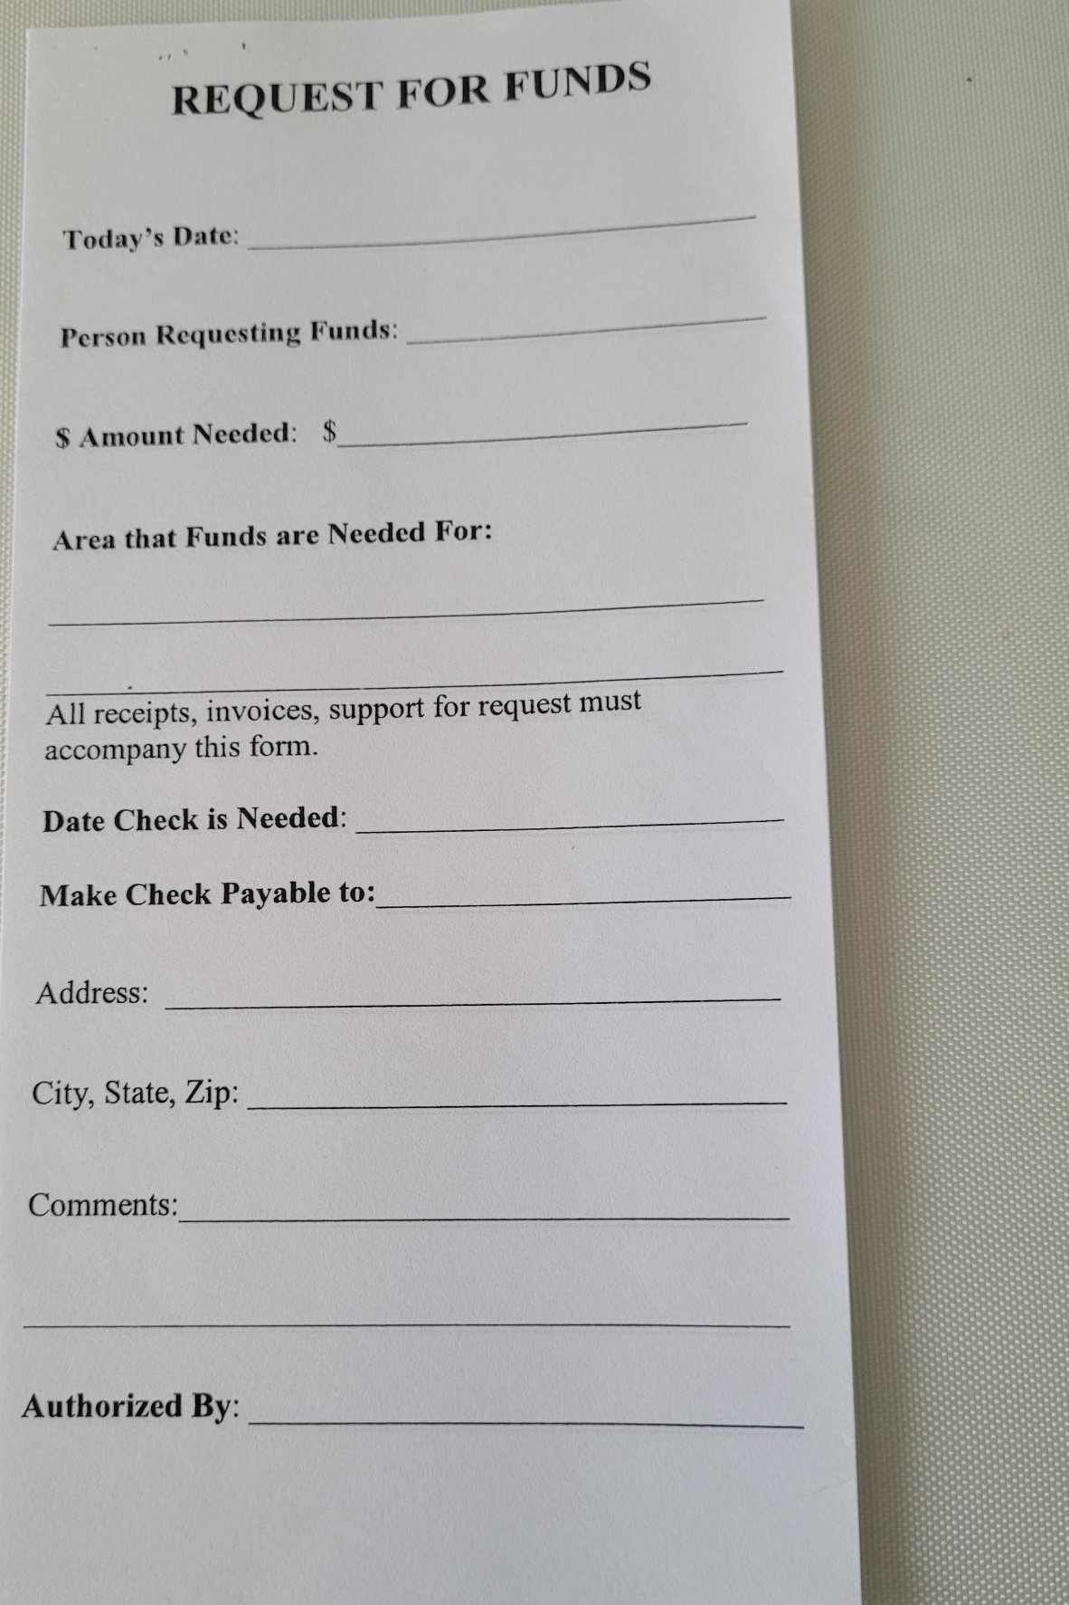

11-11-2023 6

