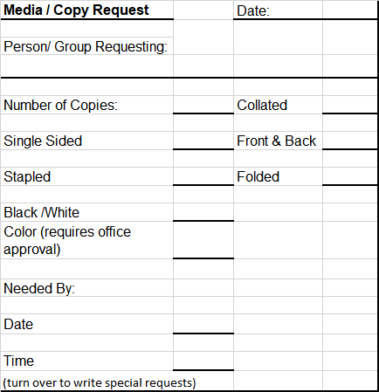

- Submit to Office 1 week ahead.

8-25-2023 5

